
ANURAG Pharmacy College
(Approved by PCI, New Delhi, Affiliated to JNTUH, Hyderabad)
Ananthagiri (V&M), Kodad, Suryapet (Dist), Telangana. 508206
Mobile: 9553122271. Email: principal.pharmacy@anurag.ac.in
Website: www.anuragpharmacy.ac.in

2.6.2 Attainment of program outcomes, program specific outcomes and course outcomes are evaluated by the institution

The achievement of efficient program outcomes, program specific outcomes and course outcomes becomes primary for the successful running of an educational institution. To ensure the same, the institution follows the system of evaluation.
The Question paper is mapped using course outcomes and Blooms taxonomy in I Mid, II Mid examination for B.Pharmacy, M. Pharmacy and I Mid, II Mid, III Mid examination for Pharm.D
Each midterm examination carries marks of 25 for B.Pharmacy, M. Pharmacy and 30 marks for Pharm.D .These marks are distributed to test understanding of the topic by the student in depth.
Each midterm examination consists of Part- A (Long Answers) for 10 marks and Part- B (Objective Answers) for 10 marks with duration of 90 Minutes and an assignment carrying 5 marks.

Semester End Examination: Semester End examination is a metric for assessing whether each Cos are attained or not. Examination is more centered around achievement of course outcomes and program outcomes using a descriptive exam.

Assignment: Each and every student is assigned with course related tasks during every course work and assessment will be done based on their performance.

Rubrics are formulated for the assessment of Laboratory, Major Project, Seminar and Internship courses record the attainment of Course Outcomes of all courses with respect to set attainment levels.

The expected target level of course outcomes are set in the range of 3-5 scale based on the understanding level of CO by course instructor at the opening of the semester. The performance of the students in the examinations during the semester in each course is used to calculate the level of direct attainment of the COs the questions of each examination are mapped to the course outcomes by the course instructor.
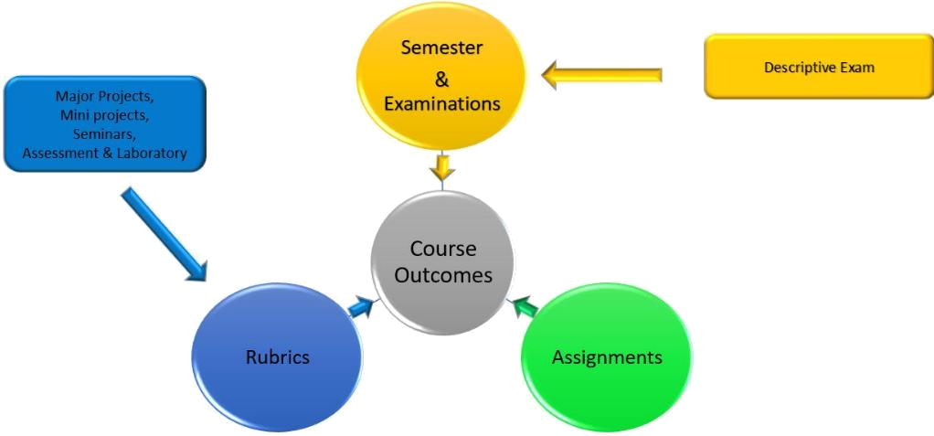

Attainment of Program Outcomes and Program Specific Outcomes:

A. List of assessment tools & processes:

- Direct assessment: The performance of the students in the examinations during the semester in each course is used to compute the level of attainment of the POs and PSOs through the mapping of questions to COs and COs to POs and PSOs. CO-PO & PSO mapping for all the courses in the program are prepared by the program coordinator.

- Indirect assessment: The feedback is collected from the students at the end of program (Program Exit Survey) and end of the course (course End survey).

The attainment of the PO & PSO is computed as a weighted average of attainment of the COs that are mapped to the given PO&PSO. The overall PO & PSO attainments are calculated by considering 70% of direct attainment and 30% of indirect attainment through surveys. Out of 30% of indirect attainment, 15% weightage is given for program exit survey, 15% for employer survey.

