**6.2.1: The functioning of the institutional bodies is effective and efficient as visible from policies, administrative set up, appointment and service rules, procedures, deployment of institutional strategic /perspective / development plan**

It must "guarantee excellence" in all activities, per the organization's strategy and strategic plan. The institutional entities' successful and effective operation is clear from their policies, administrative setup, hiring procedures, service standards, and other factors. The institution's framework primarily focused on

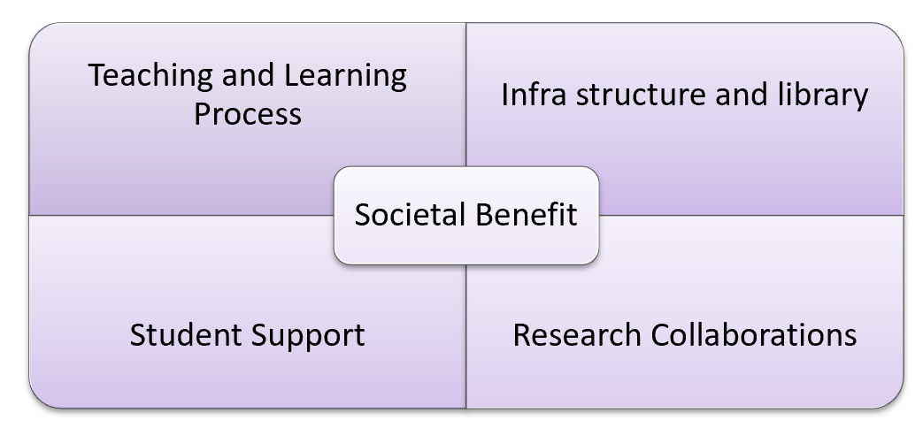

**TEACHING AND LEARNING PROCEDURE:** To attain and sustain high academic performance through a system of mentorship, feedback on the way instruction is delivered, and frequent student evaluations based on assignments, presentations, and sessional tests.   
The college boasts first-rate academic facilities, including a state-of-the-art building, numerous well-ventilated classrooms, laboratories for conducting required practical’s, a machine room for creating various formulations, and central equipment for research and consulting. It also has a library, a medicinal garden, a play area, a dorm for both male and female students, and more than 60 computers for instruction and study.

In addition to 7316 volumes and 909 titles, the library also has 25 journals, 207 e-journals, and 6 newspapers. It is designated as an NDLI club under the Indian National Digital Library and is a member of DELNET.

**SUPPORT FOR STUDENTS**   
The university's grievance redressal cell/disciplinary committee, anti-ragging committee and squad, and feedback system are in charge of verifying, coming up with a plan to deal with the issues, and coordinating discipline on campus.   
To promote the empowerment of women and girls, the Women Empowerment Cell, and Internal Complaint Committee were founded. Numerous initiatives were implemented in partnership with governmental and social organizations to raise awareness of health-related concerns and gender parity. Student-centered learning processes are emphasized through the holding of seminars, poster contests, soft skills training programs, and practical internship training that includes case studies and their analysis. Students were encouraged to take part in extracurricular activities like conferences, sports alliances, and other intra- and inter-curricular events by the cultural and sports committees.

**RESEARCH AND PARTNERSHIPS**   
The organization has a committee for industry research and consultancy, a patent cell, and supported and sponsored activities because the university has recognized it as a research center. As they strive to increase their expertise and take part in research publications, these committees help and encourage postgraduate students and teaching personnel. The organization requests submissions for research funds and recommendations for the purchase of pricey equipment from PhD holders. Additionally, it offers financial assistance for lectures, conferences, workshops, and FDPs and assists junior staff in enrolling in PhD programs.   
**SOCIAL OUTCOMES AND CONTINUING DEVELOPMENT FOR SOCIAL GAIN**   
The institution's National Service Scheme (NSS), sports and cultural committee, and other departments organize national and international days with IQAC's help. They also run health camps, blood donation camps, and health awareness programs with the assistance of medical specialists from several reputable hospitals, in addition to regular camps, special programs, and outreach projects for societal welfare.